Answers
Task 1
- Look at the sound wave below and record the samples in the table beneath it. The first two are done for you. You can only plot a sample at an intersection. Use a ‘best-fit’ approach.
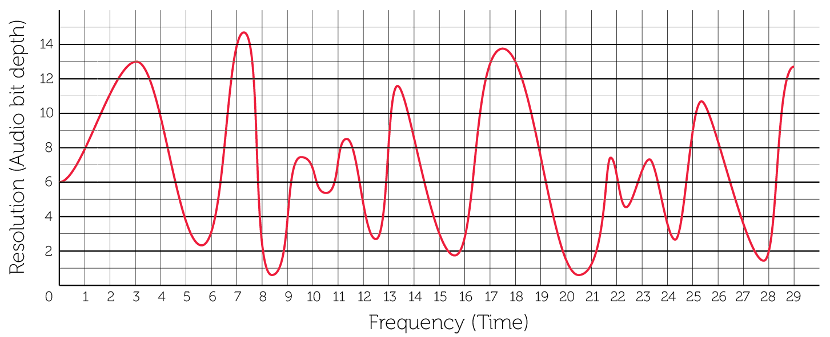
0 | 1 | 2 | 3 | 4 | 5 | 6 | 7 | 8 | 9 | 10 | 11 | 12 | 13 | 14
6 | 8 | 11 | 13 | 9 | 4 | 3 | 14 | 2 | 3 | 7 | 7 | 5 | 8 | 8
15 | 16 | 17 | 18 | 19 | 20 | 21 | 22 | 23 | 24 | 25 | 26 | 27 | 28 | 29
3 | 3 | 13 | 13 | 7 | 2 | 1 | 6 | 7 | 4 | 9 | 8 | 4 | 2 | 13
(There is some margin for error in each of these points)
- Replot all of your figures on to the graph below and create a bar chart from the points. The first two points have been drawn for you.
Completed graph:
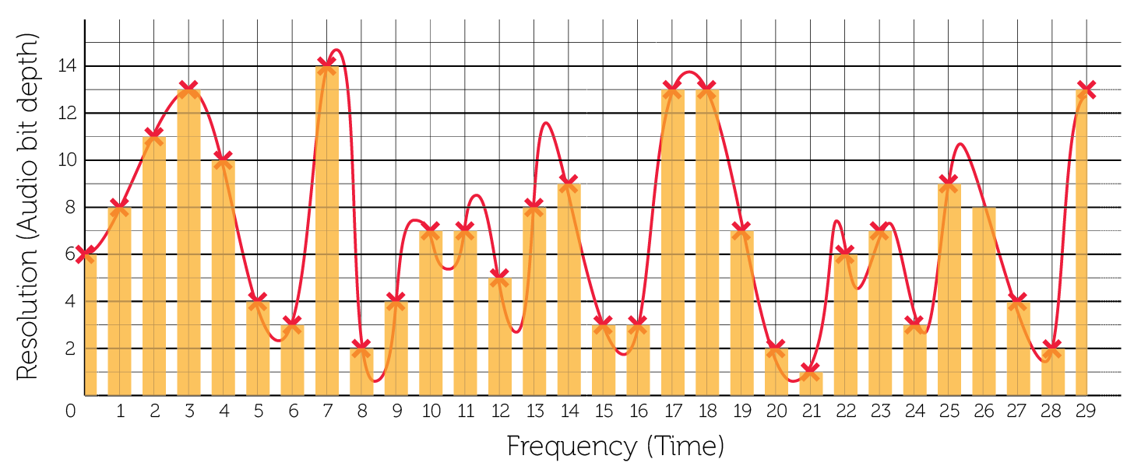
- How accurately does this represent the original sound wave? Where are there inaccuracies in the digital reproduction of the wave?
The wave is reproduced with reasonable accuracy, to the point that you might actually recognise the tune (albeit in poorer quality) if this were a real practical example. The peaks and troughs of the wave are not represented accurately in the reconstructed drawing.

Task 2
- What would you need to do in order to improve the accuracy of the recording?
Take samples more frequently and increase the resolution (bit depth) so that it is more accurate on the y-axis.
- In reality, each of the measurements on the y-axis would be given a binary value and that would be recorded in the audio data file. Using Table 1 below write out the binary values for each of the first ten samples given in Table 2. There are 16 sampling points on the y-axis so four bits must be used in order to provide enough different bit patterns for each sampling point.
Y | Bit value
1 | 0001
2 | 0010
3 | 0011
4 | 0100
5 | 0101
6 | 0110
7 | 0111
8 | 1000
9 | 1001
10 | 1010
11 | 1011
12 | 1100
13 | 1101
14 | 1110
15 | 1111
Table 1
Sample | 0 | 1 | 2 | 3 | 4 | 5 | 6 | 7 | 8 | 9
Value | 6 | 8 | 11 | 13 | 10 | 4 | 6 | 14 | 2 | 4
Binary value | 0110 | 1000 | 1011 | 1101 | 1010 | 0100 | 0110 | 1110 | 0010 | 0100
Table 2
The Binary Values in the third row above represent the data that would be stored to recreate this very short sound file of 10 samples.
- What would be the file size in bytes of the 10 samples in Question 3?
10 samples, each using 4 bits = 40 bits / 8 = 5 bytes
The resolution is the accuracy with which the wave height is measured – the higher the resolution, the more accurate the measurement at a particular sample point.
- What would the file size of samples in question 3 become if you increased the resolution to allow for 256 different points on the y-axis?
256 points would require 8 bits. 8 x 10 = 80 bits or 10 bytes.

- How would this affect the quality of the recording?
The recording quality would increase since the wave height with each sample could be recorded 16 times more accurately.
- The sampling frequency is the frequency with which the measurements are taken – a higher sampling frequency means measurements are taken more often within the same period of time. How would this affect the quality of the recording?
The more often you are able to sample, the more accurately you can record changes in the wave height, and therefore the more accurately you can reproduce the recording digitally to create a higher quality output.
- Explain the relationship between the quality of playback and the file size.
As quality of playback increases, owing to a greater number of samples or a greater sampling accuracy, the more data is generated, and therefore the larger the sound file.
- Calculate the file size in mebibytes of a music track that has the following properties:
- Resolution: 16-bits
- Sample rate: 44.1 kHz
- Length: 3 minutes 30 seconds
File size = sample rate x resolution x duration
File size = 44.1 kHz x 16 bits x 3m 30s
File size = 44100 Hz x 16 bits x 210s
File size = 148 176 000 bits
File size = 148 176 000 / 8 = 18 522 000 bytes
File size = 18 522 000 / (1024²) = 17.66 mebibytes/MiB
Note: The answer to this question assumes that the sound has been recorded in mono. Sound is normally recorded in stereo, but channels are not part of the iGCSE specification. Students may be interested that CDs have a resolution of 16 bits, sample rate of 44.1 kHz and a stereo track, so the above answer would need to be doubled to show the storage required on an audio CD.

